|  |
| --- |
|  |

**Effect of Screen Time on Quality of Sleep**

*Anish Philip, Swati Akella, Sarah Iranpour*

*Spring 2020 W241 Section 2 Final Project*

# 1 - Abstract

Technology has shifted people’s lives, including their routines prior to bed. Today, most people use some sort of electronic device before going to sleep. Though researchers are claiming this habit changes sleep quality, it is not clear if the length of phone usage prior to bed affects sleep quality. Does 10 to 15 minutes of not using electronic devices prior to sleep change sleep quality?

We studied this by recruiting subjects to participate in a two-week experiment, where one week they were assigned to a placebo group and another week they were assigned to a treatment group. The placebo intervention required participants to read articles from their phones prior to sleep and the treatment intervention required participants to read paper articles prior to sleep. Overall, the results did not show significant differences between the placebo and treatment group.

2 - Background

It has been well documented that sleep is very important to overall health. Many people spend most of their day looking at screens and according to the National Sleep Foundation[1], “90% of people in the US admit to using a technological device during the hour before turning in.” They state that using electronic devices before bed interferes with your internal clock and may suppress the sleep-inducing hormone, melatonin. This can lead to disruptions in a person’s sleep cycle and change their sleep quality. There has been other independent research[2] conducted, in which it was determined that there was a correlation between increased smartphone usage and sleep disturbance.

2.1 Research Question and Hypothesis

Our research question is as follows: ***Does 10 to 15 minutes of not using electronic devices prior to sleep change sleep quality?*** In this experiment, we will define electronic devices such as phones, laptops, iPads, gaming devices, and televisions.

The following statements are our null hypothesis and alternate hypothesis:

**Null Hypothesis:** Screen time 10 to 15 minutes before going to bed does not affect the quality of sleep

**Alternate Hypothesis:** Screen time 10 to 15 minutes before going to bed changes the quality of sleep

3 – Methods

To test this hypothesis, we conducted a blocked crossover repeated measure experiment. Participants were assigned an activity that either involved the use of an electronic device or another activity that prevented their electronic device usage. Next morning, the participants self-reported the quality of their sleep which was obtained using a survey.

3.1 Participant Recruitment

Participants were recruited from our internal networks, such as coworkers, relatives, and friends. We hoped that having a personal relationship with the subjects would result in higher compliance rates and honesty. Each of us reached out to friends and family via text message or email. We explained the study, tasks they would have to complete, and asked if they would like to participate. In each household, we chose only one person to participate in order to avoid interference. This effort resulted in 57 participants.

3.2 Pilot Study

We conducted a short pilot study prior to the experiment to help finalize the morning survey questions and our decision to assign readings. We noticed there were less compliance issues when participants were assigned a task to complete. Initially we had wanted to assign 30 minutes of reading prior to sleep. However, after the pilot study, we decided to lower that time to 15 minutes.

3.3 Baseline and Covariates

A survey was constructed to collect baseline data about the participants. Also, the experiment was introduced to the participants as a morning recall/awareness study to avoid any unconscious bias towards the self-reported sleep score. The information needed was categorized into five buckets:

1. **General Information:** Collecting basic background information like age, gender, employment status and education informed us if there was a glaring variation that would require blocking.
2. **Living Conditions:** Number of persons living with the participant and number of children, especially young children can greatly influence the quality of sleep. We also collected data on the type of house (single home or apartment), neighborhood (city or suburb) and neighborhood noise level.
3. **Current Reading habits:** Based on the pilot study, we realized that we had to prescribe an activity so that participants were forced to engage in screen-time in placebo or no screen-time in treatment groups. In order to understand the current reading habits and likelihood of success if we decided to use reading as a tool, we decided to collect some information on the current reading and morning reading recall of the participants. Reading was also included in the questionnaire to mask the true intent which was device usage.
4. **Current Screen Time**: We wanted to ensure that we collected data on the current screen time exposure and block on it so that both, placebo and control had a similar mix of participants.
5. **Current Sleep Quality Metrics**: The baseline sleep quality metrics collected included bedtime, wake up time, current sleep quality score based on a 7-point Likert scale. We also created a sleep quality measure that was based on the sum of three different sleep disturbance and efficiency measures. This included the amount of time it took to fall asleep in the night, amount of interrupted sleep time, and how early the participant woke up from the intended wake-up time. These were also the outcome measures we were interested in collecting.

3.4 Outcome Measures

In this experiment, we were interested in the self-reported subjective sleep quality reported by the participant. In order to capture sleep quality, we requested the participant select an overall sleep quality based on a seven-point Likert quality scale which helped maintain a good balance between points of discrimination without adding confusion of too many response options.

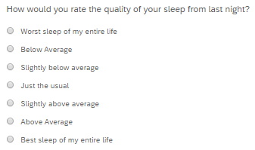

Figure 1: Sleep Quality Rating

In order to capture sleep disturbance and efficiency, we asked the participant to select a quality measure for time taken to fall asleep, interrupted sleep time and if they woke up before the intended wake-up time. These measures were added into one metric representing disturbed sleep quality score.

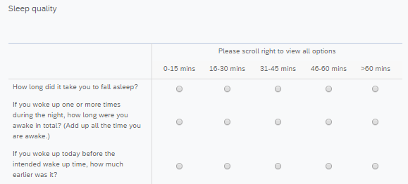

Figure 2: Interrupted Sleep Quality Metrics

3.5 Randomization

The 57 participants were assigned to placebo and treatment groups using blocked randomization. Due to the limited sample size, increasing the number of blocks caused an imbalance in the composition of the two groups. To prevent this imbalance, the number of blocks were restricted to current screen time exposure in the evenings and participants with children younger than 5 years of age. Each participant was assigned to both placebo and treatment groups. Creating randomized groups each week was important as lower compliance was anticipated in week 2.

Baseline distributions of each group were checked to ensure that there was not a significant variation between placebo and treatment.

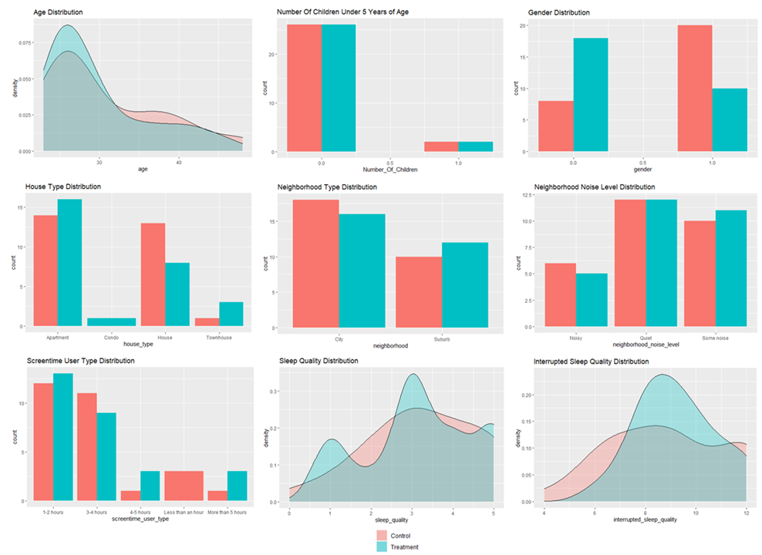

Figure 3: Distribution of covariates

3.6 Details on Treatment

The duration of the study was 10 days. The 10 days were split equally over the span of two weeks (Sunday through Friday for each week). Participants were assigned a reading beginning Sunday night through Thursday night. We chose to only assign readings on nights where the next day was a weekday. This decision was made because people’s weekend sleep behavior may not be consistent with their weekday sleep behavior. They were asked to complete a survey the following morning (Monday through Friday). Table 1 shows the participants’ reading and survey schedule.

Table 1: Experiment activity schedule

|  |  |  |  |  |  |  |
| --- | --- | --- | --- | --- | --- | --- |
| **Week 1** | **Sunday** | **Monday** | **Tuesday** | **Wednesday** | **Thursday** | **Friday** |
| **Morning** |  | Survey | Survey | Survey | Survey | Survey |
| **Night** | Read | Read | Read | Read | Read |  |
| **Week 2** | **Sunday** | **Monday** | **Tuesday** | **Wednesday** | **Thursday** | **Friday** |
| **Morning** |  | Survey | Survey | Survey | Survey | Survey |
| **Night** | Read | Read | Read | Read | Read |  |

We anticipated compliance would be an issue, especially during the week where participants were asked not to use their phones before sleep. Instead of simply asking participants to use or not use electronic devices prior to going to sleep, we assigned nightly readings. This was a method to get the participants to comply by having them complete a task each night.

We also anticipated the participants would forget to complete the readings. Each night, the participants would receive a text message at 8pm to remind them of their tasks. The participants in the treatment group received the text message in Figure 4 (C). The reminder also included the link to the treatment group’s assigned reading for easy access. Participants in the placebo group received the text message in Figure 4 (A). The readings for the placebo group were printed and mailed to each participant. We included a statement to ask those who did not receive a packet to read any book, magazine, or printed articles they had available at home. After completing the readings on the proper mediums for 10-15 minutes, the participants were instructed to go to sleep.

The following morning, all participants received the same text message with the morning survey link that can be seen in Figure 4 (B). The morning survey was sent out to each participant within the hour they typically wake up. For example, if a participant indicated they typically wake up between 5:00 – 6:00 AM, they received the morning survey at 6:00 AM. By doing this, we hoped the participants would complete the morning survey as close to their wake-up time as possible for the most accurate results.

|  |  |  |
| --- | --- | --- |
| **Nightly Reminders with link to Placebo Reading (A)** | **Morning Survey Reminder and Link (B)** | **Nightly Reminder during Treatment Week (C)** |
|  |  |  |

Figure 4: Text messages sent to participants during the experiment

All participants took part in the placebo group and the treatment group at some point in the study. They were randomized equally to the placebo group and treatment group in week 1. In week 2, they switched groups. The placebo group became the treatment group, and the treatment group became the placebo group. This is shown in Figure 5.

The placebo group and treatment group are defined as follows:

**Placebo Group:** Participants in the placebo group will use their electronic device to complete the assigned reading for 10 to 15 minutes.

**Treatment Group:** Participants in the treatment group will complete the assigned reading on paper for 10 to 15 minutes.

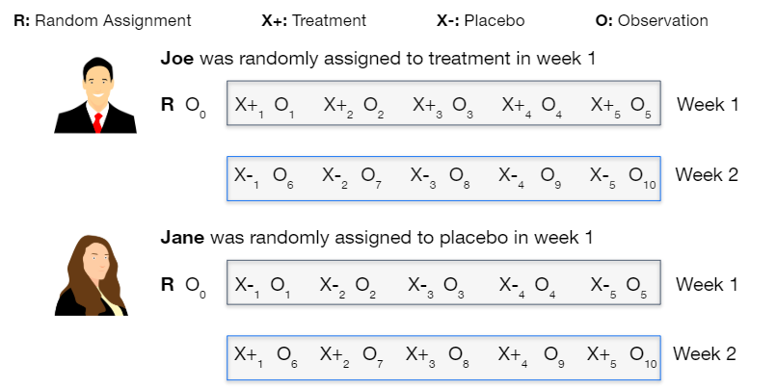

Figure 5: Placebo and Treatment groups

To begin the study, all participants were asked to complete a baseline questionnaire regarding the following topics:

1. General participant information (age, gender, employment status, and education)
2. Living conditions (cohabitants, house type, neighborhood, and neighborhood noise level)
3. Current reading habits
4. Current screen time (screen time usage in the evening and 15 minutes prior to sleep)
5. Sleep metrics (sleep time, wake up time, sleep quality, time to fall asleep, interrupted sleep time, and waking up earlier than intended wake up time

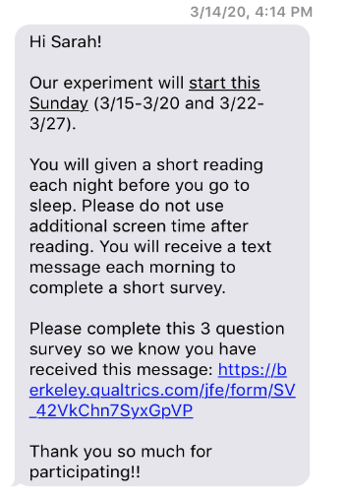

Figure 6: Baseline data collection survey

3.7 Collecting data from experiment

We grouped participants by their wake-up time adjusting for the time zone difference. In the morning, each participant received a text message with the sleep quality questionnaire within the hour of their wake-up time. This was important as we believed that accuracy of data would have been diluted if the information were collected farther away from the participants’ wake-up time.

The morning survey was designed to be short and could be completed in a minute. Since we were collecting data over 10 days, we did not want to risk attrition by increasing the complexity and time commitment required by the participants.

In order to verify compliance, we asked if the participant had completed the assigned task just before going to sleep and if the participant used an electronic device 15 minutes prior to bedtime. This information formed the basis to differentiate compilers and non-compliers.

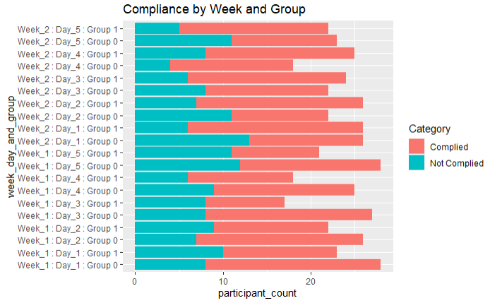

Figure 7: Comparing compliance each day of the experiment between placebo and treatment groups

Anticipating compliance issues in treatment, we had mailed reading packets. However, due to the COVID-19 lockdown not all packets reached the treatment group on time. This led to lower compliance in the treatment group. In Figure 7, you can notice that many participants did not fill out the survey next morning in the treatment group. Moreover, in most of the days, the non-compliers in treatment group was higher compared to placebo group. We were missing 91 observations for 33 unique participants.

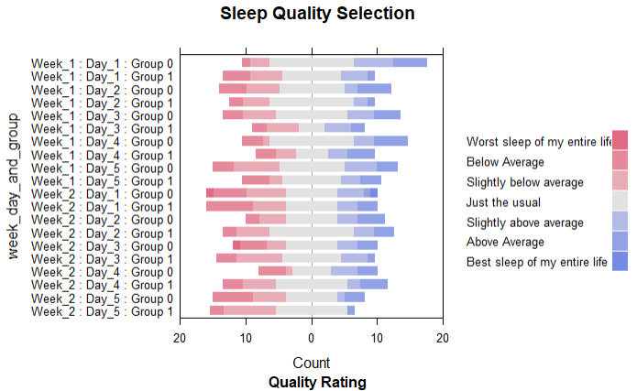

Figure 8: Overall sleep quality selections by group for each experiment week and day

In Figure 8, you can notice that as the experiment progresses, the sleep quality selected by participants tends to fall below average. It is difficult to determine, how much of this deterioration in quality can be attributed to COVID-19. This is further explored under section 4.5.

4 - Results

4.1 Attrition and Compliance

In context of this experiment, attrition was defined as those who dropped out of the study after week 1. Compliance for the placebo group was defined as those who completed the reading at night and used electronic devices 15 minutes prior to going to sleep. Compliance for the treatment group was defined as those who completed the reading at night and did not use electronic devices 15 minutes prior to going to sleep.

Figure 9 is a flow chart of our observation tracking. We expected to receive 10 observations from each of the 57 participants. If the compliance rate was 100% over two weeks, we should have received 570 observations. Instead, we received 468 observations. Of the 468 observations, 302 observations were considered compliant.

As mentioned previously, we decided to assign readings because we anticipated compliance issues, especially during the treatment week. Due to COVID-19, there were some participants who did not receive the reading packet and were asked to complete self-readings. However, as anticipated, lower compliance was observed among the participants who were asked to do the self-readings. Three participants dropped out during week 1.

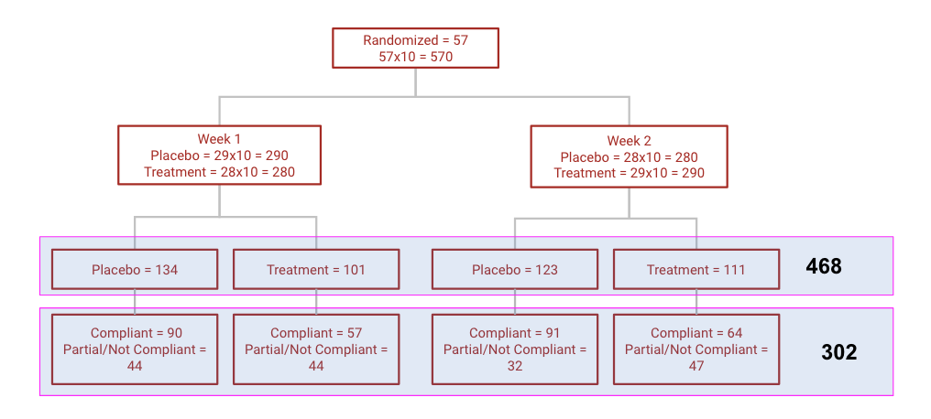

Figure 9: Participant flow chart

4.1.1 Missing Observations

A sensitivity analysis of missing data (a candidate who did not submit a morning survey) shows that the missing data is not random. There is a steady pattern in the “Missing Treatment” (number of missing observation/ participants: Table 2)

1. We observed that people with 1 or more children in the household are missing on an avg 3.98 more observation (out of 10) across treatment and control weeks
2. Participants with higher baseline screen time are missing 0.511 observation with every additional hour of reported screen time

Table 2: Sensitivity analysis for missing data

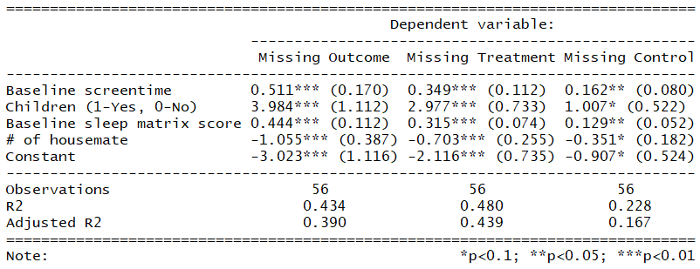

4.1.2 Compliance in Treatment and Placebo

Compliance was also differentiated by the class of treatment (i.e. placebo vs actual treatment). Participants were 21.4% less compliant when they were in treatment week than in placebo. Which indicates a preference or ease of reading from electronic devices over printed material.

Table 3: Sensitivity analysis for compliance

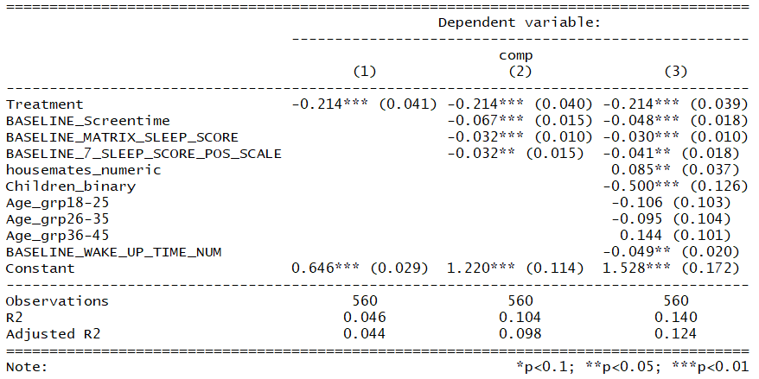

Both missing observations and compliance created a challenging situation for post treatment analytics since neither were random and the treatment effect among compliers could have been biased towards the participants who preferred reading from print media over electronic

4.2 Individual Observations (Longitudinal)

For 51/57 with 2 or more “compliant” observations following (Figure 6) frequency distribution was observed. Two classes of participants: (a) >= 6 compliant observations (N=23) and (b) < 6 compliant observations (N=28) were compared to identify any significant difference between mean outcome of two classes within treatment and placebo.

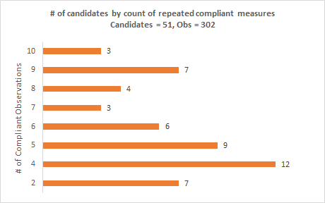

Figure 10: Frequency distribution of participants by number of compliant records

Table 4: Comparison between frequent compliers (>70%) and sporadic compliers

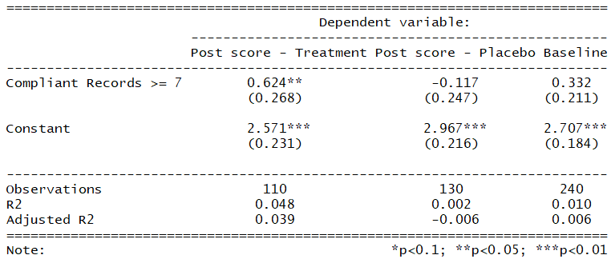

Table 4 shows that there is a difference between these two classes of participants ((a) vs (b)) within treatment observations. Meaning, a highly compliant participant (a) had 0.624 (on a scale of 0-6 scale) point higher reported post-treatment sleep quality than low compliance participants (b). This indicates that regression analysis on observation level data could return a treatment effect higher than true treatment effect.

Table 5 shows the results from regression analysis on observation level data to identify treatment effect. Model (4) shows that participants in treatment reported 0.270 (0.132) point (on a 0-6 scale) higher sleep quality.

Table 5: Regression analysis on compliant records

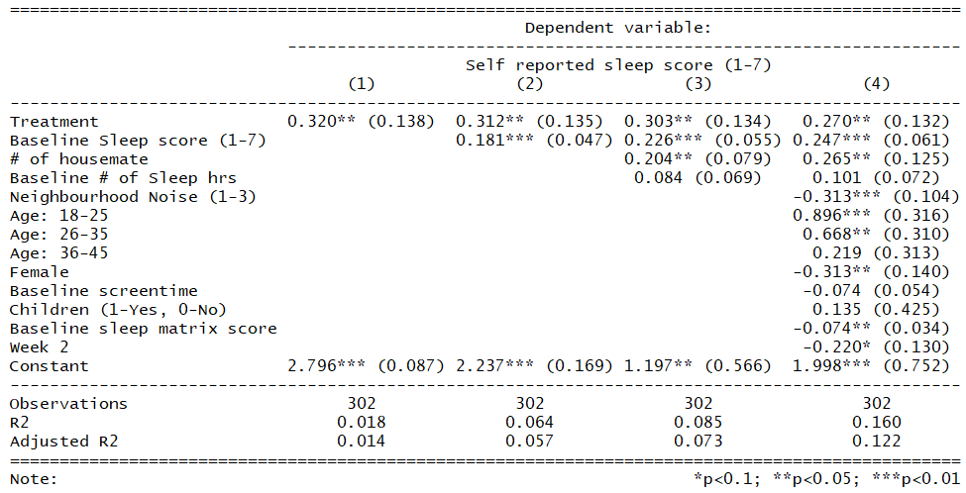

Due to the bias we spoke about in this section we move to a participant level data to identify the true treatment effect since this model provides a higher treatment effect weighted towards more compliant participants.

4.3 Individual Participants (Cross sectional data)

Table 6 shows the summary of regression analysis on participant level data. We brought the longitudinal data to cross-sectional by leveraging the average of all Treatment/ Placebo observations at a participant level. This removes the within-subject variance, but we did not find any significant difference between outcomes from different days of the treatment/ placebo weeks. All available observations (N=468) we included agnostic of compliance. This shows a negative treatment effect, but this point estimate of the difference between treatment and placebo is not statistically significant.

Table 6: Regression analysis of average scores for each participant

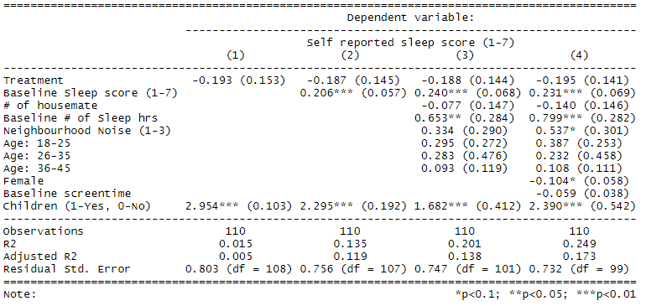

In a final iteration of participant level data analysis, we retained only those participants (N=38/ 55) who had at least 1 compliant observation across treatment and placebo week to see the true effect among compliers who followed the treatment rules. Table 7 shows the summary with treatment effect to be negative, just like across all participants in Table 6 but the difference remains statistically insignificant.

Table 7: Regression analysis of average scores of compliant participants

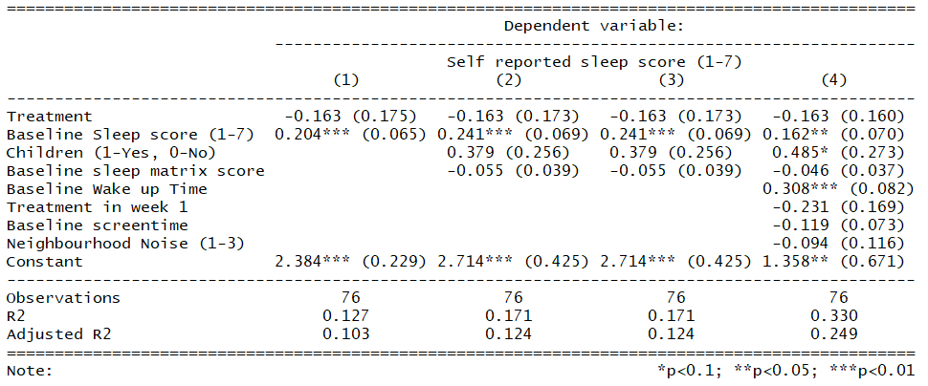

4.4 Subgroup and Heterogeneous treatment effects

Looking at the strata of participants by their baseline sleep score, we observed that participants with lower baseline sleep quality reported a more positive treatment effect (Table 8). Also, there were no significant observations from looking at the participant subgroup by age.

Table 8: Heterogenous treatment effects

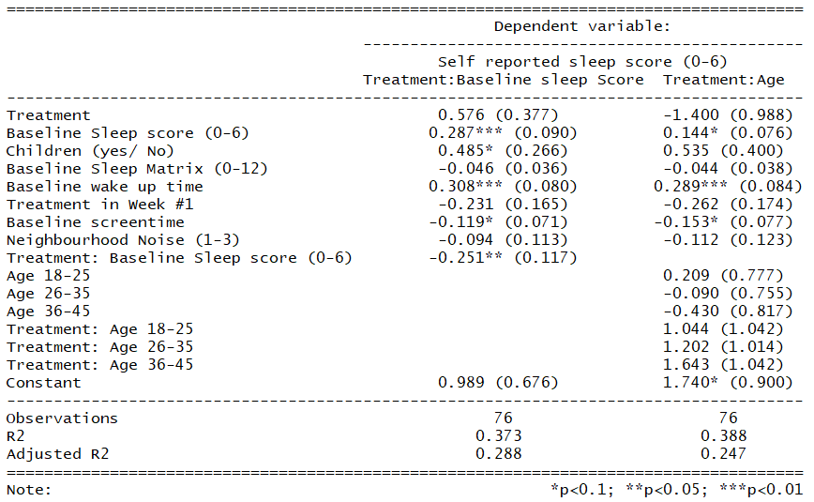

Figure 11: Observational analysis of treatment effect vs baseline sleep score shows the trend of treatment effect with the increase in the baseline score of sleep quality.

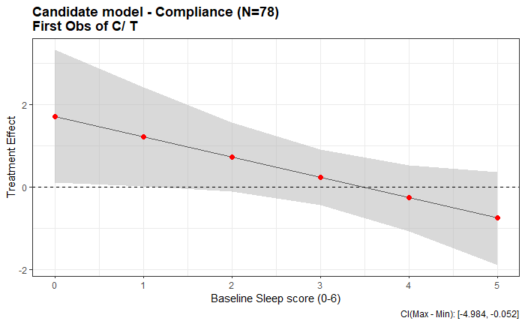

Figure 11: Observational analysis of treatment effect vs baseline sleep score

4.5 Post-experiment feedback analysis

All participants were asked to complete a short post-experiment feedback survey containing questions regarding their stress levels, sleep quality when reading on a device vs. paper, and COVID-19’s effect on sleep. The results in Table 9 are a bit conflicting. Although 59% of the respondents indicated their stress levels and sleep quality were the same in week 1 and week 2, 65% indicated COVID-19 affected their sleep.

Table 9: Post experiment survey response

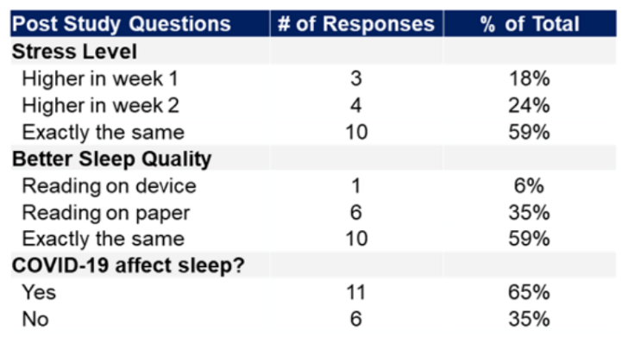

5. Limitations and future directions

Due to the short timeline of the project and limited incentives the sample population was based on friends, acquaintances and family members which might not be the most representative sample of the overall US population. We still believe that the results could be generalized among samples of working individuals of age ranging from 18 through 55 during a pandemic or national security crisis. The study was impacted by COVID-19 pandemic as seen from the lower compliance rate and missing data. We believe that it had a confounding effect on the outcome and compliance as many offices across the US started work from home mandate since mid-March 2020 impacting the normal schedules of the study participants. Many participants reported that their sleep pattern was affected negatively due to the pandemic (section 4.5 Post experiment feedback). This means the true treatment effect could be higher and more significant that we are seeing at this time (Section 4.3).

With a sample size of 57 participants we were unable to block for more than 2 behaviors collected from baseline as the N size of the blocks started shrinking. A larger sample set would have allowed for a better block randomization solving for any varying compliance, attrition rate across multiple observations. A robust randomization in cross over study would also help study get accurate and valuable information on treatment effects even in scenarios with strong confounding social and market events which would impact the accuracy of repeated measures over time when the treatment is not varying.

This study was very conservative in allocating treatment prescriptions (10-15 minutes of light reading right before going to sleep). This was done based on the finding from the pilot study where test participants (not from 57 main participants) were asked about the willingness to continue with the treatment after day-1 and they all reported the original length of reading to be too long for them to continue maintaining compliant participation.

The outcome measures of this study could be significantly improved by leveraging an alternate to capturing the outcome through self-reported surveys. With a significantly larger budget, more effective sleep tracking mechanisms could be incorporated to this design. These mechanisms could be sleep monitors from sleep clinics and/ or watches with biometric sensors. With a better incentive the study could be held inside a sleep clinic to get a more accurate and steadier stream of measured compliant outcomes. All of this while the study is being conducted in a controlled environment.

6. Conclusion

Although this analysis on sleep quality study data did not show a statistically and practically significant difference among the participants in their treatment and placebo week. In certain sub-groups, we did notice some statistically significant improvement in sleep quality when not using electronics. However, this difference could be a result of randomization. Overall, we cannot conclude that 10-15 minutes of avoiding electronic device before sleep improves sleep quality. In order to make a conclusive statement, this experiment should be repeated with a higher sample size in a environment free of health and social crisis.

1. How and Why Using Electronic Devices At Night Can Interfere With Sleep

   <https://www.sleepfoundation.org/articles/why-electronics-may-stimulate-you-bed>
2. Demirci K, Akgönül M, Akpinar A. Relationship of smartphone use severity with sleep quality, depression, and anxiety in university students. *J Behav Addict*. 2015;4(2):85–92. doi:10.1556/2006.4.2015.010